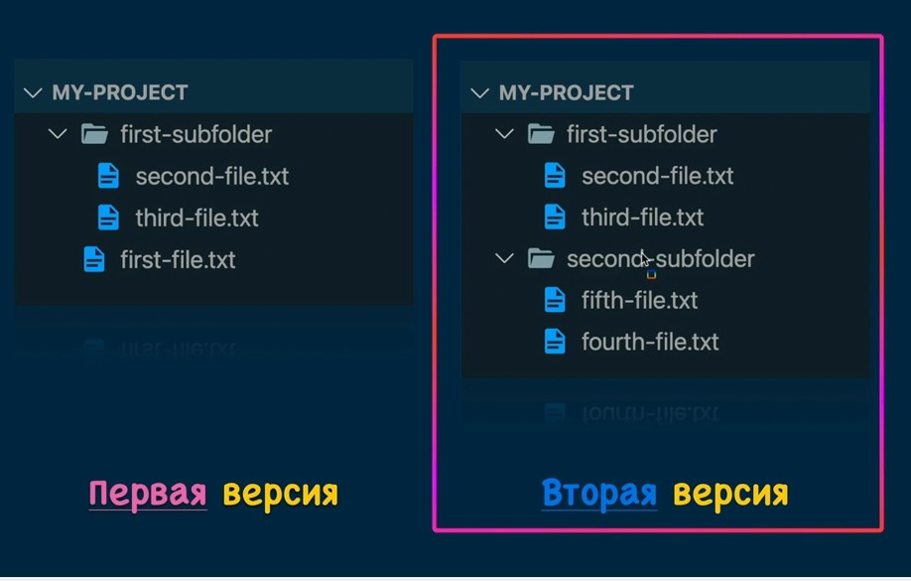

**Делаем рабочую обл.в первой версии:**

PS C:\Users\NOname> cd D:\GITexample

PS D:\GITexample> cd D:\GITexample\.git

PS D:\GITexample> git status

On branch main

No commits yet

Untracked files:

(use "git add <file>..." to include in what will be committed)

1/

nothing added to commit but untracked files present (use "git add" to track)

PS D:\GITexample> echo first-file.txt

first-file.txt

PS D:\GITexample> ls

Каталог: D:\GITexample

Mode LastWriteTime Length Name

---- ------------- ------ ----

d----- 06.10.2023 10:43 1

PS D:\GITexample> echo "first file text" > first-file.txt

PS D:\GITexample> git status

On branch main

No commits yet

Untracked files:

(use "git add <file>..." to include in what will be committed)

1/

first-file.txt

nothing added to commit but untracked files present (use "git add" to track)

PS D:\GITexample> mkdir first-subfolder

Каталог: D:\GITexample

Mode LastWriteTime Length Name

---- ------------- ------ ----

d----- 08.10.2023 8:18 first-subfolder

PS D:\GITexample> cd first-subfolder

PS D:\GITexample\first-subfolder> echo "first file text" > second-file.txt

PS D:\GITexample\first-subfolder> echo "first file text" > third-file.txt

PS D:\GITexample\first-subfolder> ls

Каталог: D:\GITexample\first-subfolder

Mode LastWriteTime Length Name

---- ------------- ------ ----

-a---- 08.10.2023 8:21 36 second-file.txt

-a---- 08.10.2023 8:22 36 third-file.txt

PS D:\GITexample\first-subfolder> cat second-file.txt

first file text

PS D:\GITexample\first-subfolder> cd..

PS D:\GITexample> git add first-file.txt

PS D:\GITexample> git status

On branch main

No commits yet

Changes to be committed:

(use "git rm --cached <file>..." to unstage)

new file: first-file.txt

Untracked files:

(use "git add <file>..." to include in what will be committed)

1/first-subfolder

PS D:\GITexample> git add .

PS D:\GITexample> git status

On branch main

No commits yet

Changes to be committed:

(use "git rm --cached <file>..." to unstage)

new file: 1/file.txt

new file: first-file.txt

new file: first-subfolder/second-file.txt

new file: first-subfolder/third-file.txt

PS D:\GITexample> git log

fatal: your current branch 'main' does not have any commits yet

PS D:\GITexample> git commit -m "FIRST COMMIT"

[main (root-commit) fafc37a] FIRST COMMIT

4 files changed, 0 insertions(+), 0 deletions(-)

create mode 100644 1/file.txt

create mode 100644 first-file.txt

create mode 100644 first-subfolder/second-file.txt

create mode 100644 first-subfolder/third-file.txt

PS D:\GITexample> git status

On branch main

nothing to commit, working tree clean

PS D:\GITexample> git log

commit fafc37a37058ced63b47b02182461a31988a7c44 (HEAD -> main)

Author: Andreikld <lynxkng@inbox.ru>

Date: Sun Oct 8 08:37:04 2023 +0200

FIRST COMMIT

PS D:\GITexample> cd .git

PS D:\GITexample\.git> ls

Каталог: D:\GITexample\.git

Mode LastWriteTime Length Name

---- ------------- ------ ----

d----- 06.10.2023 11:36 hooks

d----- 06.10.2023 11:36 info

d----- 08.10.2023 8:37 logs

d----- 08.10.2023 8:37 objects

d----- 06.10.2023 11:36 refs

-a---- 08.10.2023 8:37 13 COMMIT_EDITMSG

-a---- 06.10.2023 11:36 130 config

-a---- 06.10.2023 11:36 73 description

-a---- 06.10.2023 11:36 21 HEAD

-a---- 08.10.2023 8:37 483 index

PS D:\GITexample\.git> cd objects

PS D:\GITexample\.git\objects> ls

Каталог: D:\GITexample\.git\objects

Mode LastWriteTime Length Name

---- ------------- ------ ----

d----- 08.10.2023 8:37 28

d----- 08.10.2023 8:30 2b

d----- 08.10.2023 8:37 b1

d----- 08.10.2023 8:37 ca

d----- 08.10.2023 8:37 fa

d----- 06.10.2023 11:36 info

d----- 06.10.2023 11:36 pack

PS D:\GITexample\.git\objects> git log

commit fafc37a37058ced63b47b02182461a31988a7c44 (HEAD -> main)

Author: Andreikld <lynxkng@inbox.ru>

Date: Sun Oct 8 08:37:04 2023 +0200

FIRST COMMIT

PS D:\GITexample\.git\objects> cd fa

PS D:\GITexample\.git\objects\fa> ls

Каталог: D:\GITexample\.git\objects\fa

Mode LastWriteTime Length Name

---- ------------- ------ ----

-ar--- 08.10.2023 8:37 136 fc37a37058ced63b47b02182461a31988a7c44

PS D:\GITexample\.git\objects\fa> git log

commit fafc37a37058ced63b47b02182461a31988a7c44 (HEAD -> main)

Author: Andreikld <lynxkng@inbox.ru>

Date: Sun Oct 8 08:37:04 2023 +0200

FIRST COMMIT

PS D:\GITexample\.git\objects\fa> git cat-file -t fafc37a

commit

PS D:\GITexample\.git\objects\fa> git cat-file -p fafc37

tree 286011f611efbf95c52e9b3d1cd31bbd3da41ee4

author Andreikld <lynxkng@inbox.ru> 1696747024 +0200

committer Andreikld <lynxkng@inbox.ru> 1696747024 +0200

FIRST COMMIT

PS D:\GITexample\.git\objects\fa> git cat-file -t 286011f61

……………………………………….

Делаем рабочую обл. во второй версии:

Удаляем фаил first-commit просто в корне и добавляем в корень 2 папки



PS D:\GITexample>> rm first-file.txt

PS D:\GITexample> git status

On branch main

Changes not staged for commit:

(use "git add/rm <file>..." to update what will be committed)

(use "git restore <file>..." to discard changes in working directory)

deleted: first-file.txt

Untracked files:

(use "git add <file>..." to include in what will be committed)

"~$\320\276\320\272\320\270 GIT .docx"

~WRL0003.tmp

"\320\243\321\200\320\276\320\272\320\270 GIT .docx"

no changes added to commit (use "git add" and/or "git commit -a")

PS D:\GITexample> mkdir second-subfolder

Каталог: D:\GITexample

Mode LastWriteTime Length Name

---- ------------- ------ ----

d----- 09.10.2023 20:16 second-subfolder

PS D:\GITexample> cd second-subfolder/

PS D:\GITexample\second-subfolder> echo "forth file text" >forth-file.txt

PS D:\GITexample\second-subfolder> echo "fifth file text" >fifth-file.txt

PS D:\GITexample> git add .

PS D:\GITexample> git status

On branch main

Changes to be committed:

(use "git restore --staged <file>..." to unstage)

deleted: first-file.txt

new file: second-subfolder/fifth-file.txt

new file: second-subfolder/forth-file.txt

new file: "~$\320\276\320\272\320\270 GIT .docx"

new file: ~WRL0003.tmp

new file: "\320\243\321\200\320\276\320\272\320\270 GIT .docx"

PS D:\GITexample> git commit -m "Second commit"

[main 1f1647b] Second commit

6 files changed, 0 insertions(+), 0 deletions(-)

delete mode 100644 first-file.txt

create mode 100644 second-subfolder/fifth-file.txt

create mode 100644 second-subfolder/forth-file.txt

create mode 100644 "~$\320\276\320\272\320\270 GIT .docx"

create mode 100644 ~WRL0003.tmp

create mode 100644 "\320\243\321\200\320\276\320\272\320\270 GIT .docx"

PS D:\GITexample> git status

On branch main

nothing to commit, working tree clean

PS D:\GITexample> git log

commit 1f1647b3e8d32eb9dd7043c705ae900e5df96310 (HEAD -> main)

Author: Andreikld <lynxkng@inbox.ru>

Date: Mon Oct 9 20:33:55 2023 +0200

Second commit

commit fafc37a37058ced63b47b02182461a31988a7c44

Author: Andreikld <lynxkng@inbox.ru>

Date: Sun Oct 8 08:37:04 2023 +0200

FIRST COMMIT

PS D:\GITexample> git cat-file -t 1f1647b3e

commit

PS D:\GITexample> git cat-file -p 1f1647b3e

tree a27ecd23d431cfc25e6d4ffc2942a93a22aebca3

parent fafc37a37058ced63b47b02182461a31988a7c44

author Andreikld <lynxkng@inbox.ru> 1696876435 +0200

committer Andreikld <lynxkng@inbox.ru> 1696876435 +0200

Second commit

PS D:\GITexample> git cat-file -p a27ecd23d43

040000 tree b187a4989c29adca483e4b747f624cbc29a16e8a 1

040000 tree ca2430504cfe99ef0727fe8b1e98277f57dd799c first-subfolder

040000 tree 34d6747622af997e4d555f7627345ffa888c2828 second-subfolder

100644 blob 643fdd219f1dcdd0f6ffd3ba3df89068ca271348 "~$\320\276\320\272\320\270 GIT .docx"

100644 blob d28dc746b7eed7a16b03727465847e5accdb75f4 ~WRL0003.tmp

100644 blob 9ab36549ab937a2358f0349ce8ac891c380fcb99 "\320\243\321\200\320\276\320\272\320\270 GIT .docx"

Можно аналогично просмотреть любой blob

PS D:\GITexample> git branch

* main

PS D:\GITexample> git checkout new-feature

Switched to branch 'new-feature'

M "\320\243\321\200\320\276\320\272\320\270 GIT .docx"

Удалить ветку

PS D:\GITexample> git branch -d <название ветки>

Надо перекл на др ветку PS D:\GITexample> git checkout main

Switched to branch 'main'

M "\320\243\321\200\320\276\320\272\320\270 GIT .docx"

PS D:\GITexample> git branch -d new-feature

Deleted branch new-feature (was 1f1647b).

Изменить имя тек.ветки

PS D:\GITexample> git branch -m MAIN



PS C:\Users\NOname> cd D:\GITexample

PS D:\GITexample> git checkout -b new-feature

PS D:\GITexample> git checkout

M "~$\320\276\320\272\320\270 GIT .docx"

D ~WRL0003.tmp

M "\320\243\321\200\320\276\320\272\320\270 GIT .docx"

PS D:\GITexample> git status

On branch new-feature

Changes not staged for commit:

(use "git add/rm <file>..." to update what will be committed)

(use "git restore <file>..." to discard changes in working directory)

modified: "~$\320\276\320\272\320\270 GIT .docx"

deleted: ~WRL0003.tmp

modified: "\320\243\321\200\320\276\320\272\320\270 GIT .docx"

no changes added to commit (use "git add" and/or "git commit -a")

PS D:\GITexample> git log

commit 1f1647b3e8d32eb9dd7043c705ae900e5df96310 (HEAD -> new-feature, main)

Author: Andreikld <lynxkng@inbox.ru>

Date: Mon Oct 9 20:33:55 2023 +0200

Second commit

commit fafc37a37058ced63b47b02182461a31988a7c44

Author: Andreikld <lynxkng@inbox.ru>

Date: Sun Oct 8 08:37:04 2023 +0200

FIRST COMMIT

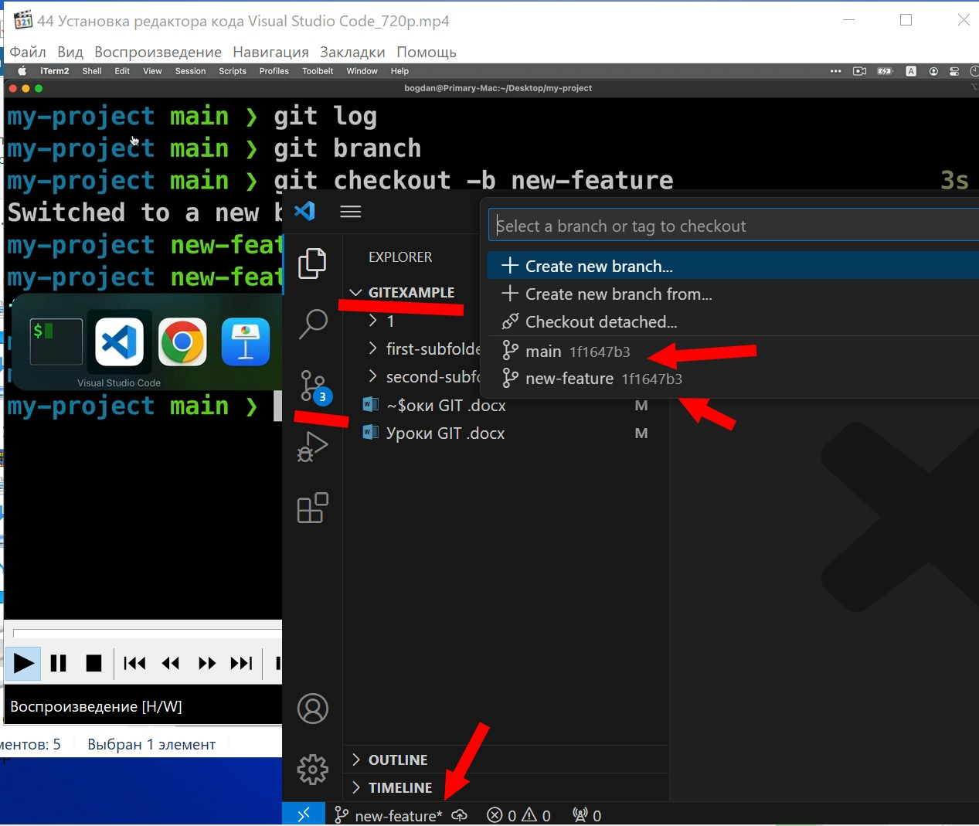

PS D:\GITexample> code . весь проект отобразился в VSC.

В редакторе кода создали фаил feature-file.txt.

Он не отслеживаемый

PS D:\GITexample> git status

On branch new-feature

Changes not staged for commit:

(use "git add/rm <file>..." to update what will be committed)

(use "git restore <file>..." to discard changes in working directory)

modified: "~$\320\276\320\272\320\270 GIT .docx"

deleted: ~WRL0003.tmp

modified: "\320\243\321\200\320\276\320\272\320\270 GIT .docx"

Untracked files:

(use "git add <file>..." to include in what will be committed)

feature-file.txt

~WRL2040.tmp

no changes added to commit (use "git add" and/or "git commit -a")

PS D:\GITexample> git add. Это добавление всех тек.изменений. Мы только что добавили в проект feature-file.txt

Поэтому Можно написать PS D:\GITexample> git add feature-file.txt

PS D:\GITexample> git status

On branch new-feature

Changes to be committed:

(use "git restore --staged <file>..." to unstage)

**new file: feature-file.txt**

Changes not staged for commit:

(use "git add/rm <file>..." to update what will be committed)

(use "git restore <file>..." to discard changes in working directory)

modified: "~$\320\276\320\272\320\270 GIT .docx"

deleted: ~WRL0003.tmp

modified: "\320\243\321\200\320\276\320\272\320\270 GIT .docx"

Untracked files:

(use "git add <file>..." to include in what will be committed)

~WRL2040.tmp

PS D:\GITexample> git commit -m "New file in the feature branch"

[new-feature 28dd53a] New file in the feature branch

1 file changed, 1 insertion(+)

create mode 100644 feature-file.txt

Изменяем фаил forth file в Second subfolder, Добавляем запись. В експлорере в VSC буква напротив фаила меняется на М. modified/ при введении git status будет указано, что forth-file.txt modified: second-subfolder/forth-file.txt

Переносим изменения в stage area, ищем forth-file.txt в VSC, жмем +.

Фаил подготовлен для коммита.

S D:\GITexample> git status

On branch new-feature

Changes to be committed:

(use "git restore --staged <file>..." to unstage)

modified: second-subfolder/forth-file.txt

в VSC жмем commit либо галочку, происходит запись изменений.

PS D:\GITexample> git log

commit 00b9bc4f08321aac085d59a7941939bf2db95256 (HEAD -> new-feature)

Author: Andreikld <lynxkng@inbox.ru>

Date: Tue Oct 10 10:58:07 2023 +0200

Modified fouth file in the feature branch

**commit** 28dd53a4472e687c4ce20d6ea34fb3571e6c7497

Author: Andreikld <lynxkng@inbox.ru>

Date: Tue Oct 10 10:36:38 2023 +0200

**New file in the feature branch**

**commit** 1f1647b3e8d32eb9dd7043c705ae900e5df96310 (main)

Author: Andreikld <lynxkng@inbox.ru>

Date: Mon Oct 9 20:33:55 2023 +0200

Second commit

**commit** fafc37a37058ced63b47b02182461a31988a7c44

Author: Andreikld <lynxkng@inbox.ru>

Date: Sun Oct 8 08:37:04 2023 +0200

FIRST COMMIT

Перейдем в ветку main в в VSC .

Изменяем в first-subfolder second-file.txt third-file.txt, добавляем sixth-file.txt